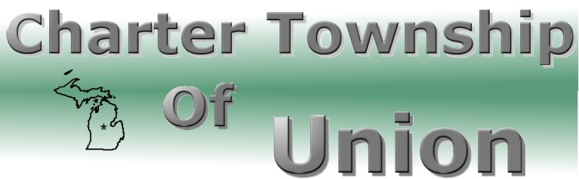

BOARD OF TRUSTEES
Regular Meeting
December 20, 2012
7:00 p.m.

- CALL MEETING TO ORDER

- PLEDGE OF ALLEGIANCE

- ROLL CALL

- PUBLIC COMMENT: Restricted to three minutes regarding issues on this agenda

- REPORTS/BOARD COMMENTS

- APPROVAL OF AGENDA

- CONSENT AGENDA
- Communications
- Minutes – December 6, 2012 Regular Meeting
- Bills
- Payroll

- BOARD AGENDA
- 2013 Budget
- Public Hearing
- Adoption
B. Portable Generator Purchase
C. Committing of EDA Fund Balance
D. Vision for Township Lists

9. EXTENDED PUBLIC COMMENT

10. FINAL BOARD MEMBER COMMENT

11. ADJOURNMENT

